4 P’s Marketing Mix Template

This template addresses how to use one of the oldest marketing concepts in today's world:
"The Marketing Mix," which is based on the 4 P's:

Product
Price
Place
Promotion

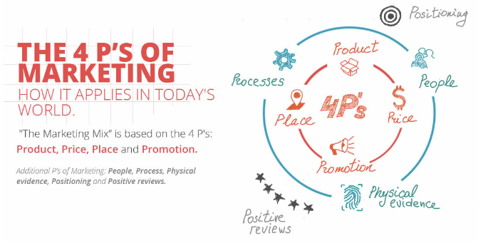


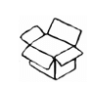PRODUCT

Question | Example | Your Answer
Who is your target customer? | - homeowner  - 29-59 years old  - lives in London  - 60K+ annual income  - have children | - College and university students  - 17-27 years old  - Tech savvy
What does the customer expect from your products and services? | - quick response  - high quality  - great customer service  - prestige  - status | - Fast and reliable responses.  - Strong data privacy.  - Helpful campus-specific assistance
Describe benefits | - best warranty  - saves money  - more secure  - local | - Saves time.  - Provides personalized academic and administrative help.  - Protects student privacy.
Describe features (for product) | - unique design  - higher quality  - faster  - smaller  - made of metal  - multiple colors | - AI chatbot.  - Automated form filling and appointment booking.  - Integration with campus portals and library systems.
Describe how it is different from competition | - more experienced  - high quality materials  - better reputation | - Designed specifically for students  - Integrations with university systems.  - Provides Data Security and Privacy.
How is your product/service branded? | - unique memorable branding that is consistent throughout all the physical and online channels | - Modern  - Student Friendly  - Trustable

PRICE

Question | Example | Your Answer
What is the value of your product/service to the customer? | - solves problems quickly and affordably unique and scarce  - knowledge and expertise | - Efficiency  - Convenience and Peace of mind
What is your pricing strategy and how does it compare to your competition? | - premium pricing  - entry-level pricing  - competitive pricing  - upsell strategy | - Free for basic features with a premium monthly plan for advanced integrations  - Competitive Pricing
How does the value compare to your competition? | - offers additional services for the same price  - has more experience  - has a longer life-cycle product  - needs less maintenance | - More features  - Lower cost
What are your pricing incentives for new customers? | - coupons  - other promotions | - Free premium trial  - Referrals bonuses to unlock premium features
What payment methods are available? | - financing  - credit cards  - cash  - online payment | - Credit/debit cards  - Online payments  - Campus partner billing  - Financing
What are your pricing incentives for loyal customers? | - discounts  - reward point system  - VIP offers | - Discounts  - Loyalty points

PLACE

Question | Example | Your Answer
Where do your buyers look for your product/service? | - shopping mall  - online  - locally  - internationally | - Online  - Website, Appstore  - Campus Student Organization
Do you need distribution channels? (product) | - dealers  - warehouses | - University Portals  - Appstore
Do you need a physical store? | - product needs to be tested before purchase  - large display of items | - No
Do you need a website? | - informational  - ecommerce  - blog  - social media | - Informational  - Signup  - Social media
Do you need physical product placement? | - grocery stores  - specialized stores  - corporate offices | - Posters  - QR codes  - University Promotion

PROMOTION

Question | Example | Your Answer
How will you reach your target audience? | - billboard  - radio  - online marketing  - flyers  - direct mail  - word-of-mouth | - Campus Promotion  - Social Media  - Referral Programs  - Word-of-mouth
What online promotional tactics will you use? | - search engine optimization  - social media  - email marketing  - 3rd party websites like Amazon  - content marketing  - paid media | - SEO  - Social media  - Email Marketing  - Paid media
Will you need a sales team for outbound promotion? | - sales reps for cold calling  - cold emailing | - NO
What are your competitors doing to promote their products? | - anything and everything they can, so how will you top them? | - Online ads

Resource: The 4 P’s of Marketing (and how to master it in today's world)

